**Installing Zabbix Agent2 on Ubuntu 22.04**

● Zabbix is a powerful open-source monitoring software that allows you to monitor the servers, networks, and applications.

● In this documentation I will be installing Zabbix agent on Ubuntu 22.04 .

● The Zabbix Agent is responsible for collecting system data and sending it to the Zabbix server for further analysis and storage.

**How Zabbix agent works:**

Zabbix agent can do both passive **(polling)** and active checks **(trapping)**.

The checks can be performed at an interval or based on specific times schedule. Here is the difference between passive and active checks:

**Passive checks (polling):**

● Zabbix server (or proxy) requests a value from Zabbix agent.

● Agent processes the request and returns the value to Zabbix server (or proxy).

**Active checks (trapping):**

● Zabbix agent requests from Zabbix server (or proxy) a list of active checks.

● The agent sends the results in periodically.

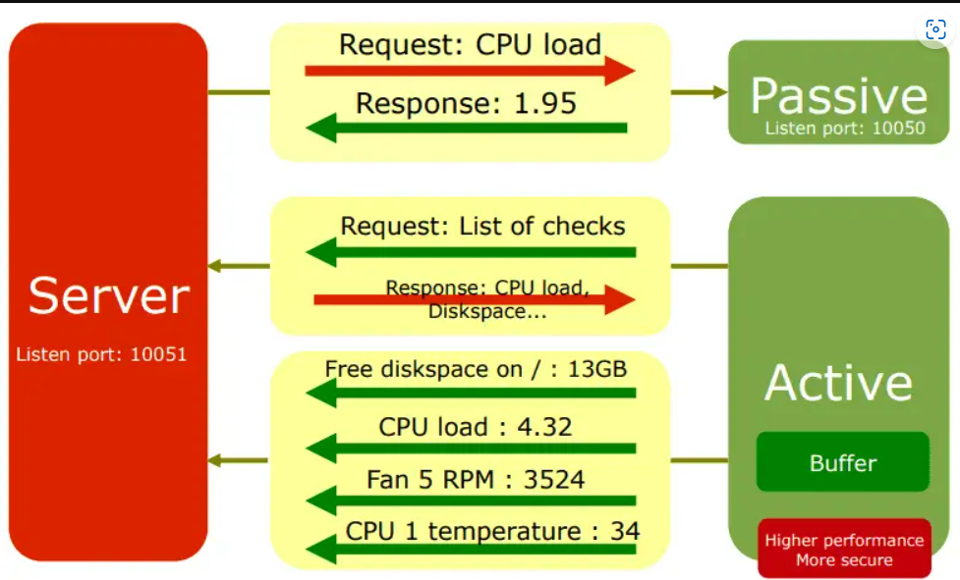

**Prerequisites:**

→ Ubuntu server 22.04 or desktop instance.

→ A user account with sudo privileges.

→ Zabbix server up and running.

**Step 1: Update your system:**

Before starting the installation process, It is always recommended to update your system. Open a terminal and execute the following commands.



**Step 2: Install Zabbix agent:**

**Note:** Here, when I am using zabbix 6.4 is the latest version.

Now, we will install the Zabbix Agent from the official Zabbix repository. First, add the Zabbix repository to your system.

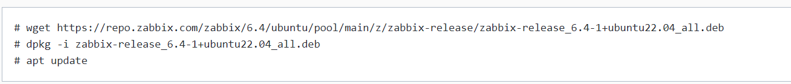

**Next, Install the Zabbix agent2:**

**zbx ag**

**Step 3: Configure Zabbix Agent:**

After the installation is complete, you need to configure the Zabbix Agent to communicate with the Zabbix server. Edit the Zabbix Agent configuration file using your preferred text editor:

nan

Find the following lines and replace them with the correct information:

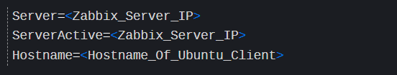

**Step 4: Start and Enable Zabbix agent2 process:**

Start Zabbix agent2 process and make it start at system boot.

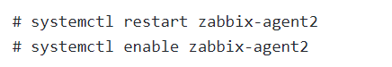

If you have ufw enabled, allow port 10050 on the firewall. This is used by Zabbix agent daemon.

# sudo ufw allow 10050/tcp

**You can check the status of the Zabbix Agent service with the following command:**

# sudo systemctl status zabbix-agent

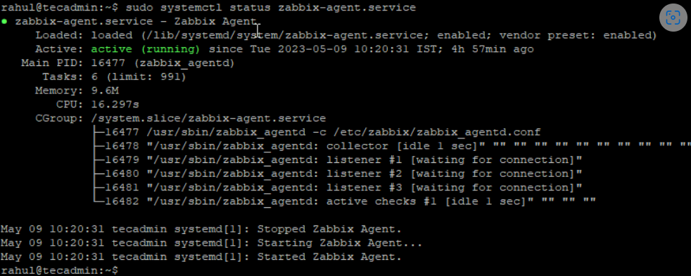

**Step 5: Add the Zabbix Client to the Zabbix Server:**

→ Lastly, you need to add the newly installed Zabbix Agent to the Zabbix server.

→ Log in to the Zabbix web interface, navigate to “**Configuration**” > “**Hosts**” > “**Create Host**”, and fill in the necessary details.

→ Select the **group** or **add a new group** for “**Groups**” field.

**IP address**

Zabbix agent service port -default is **10050**

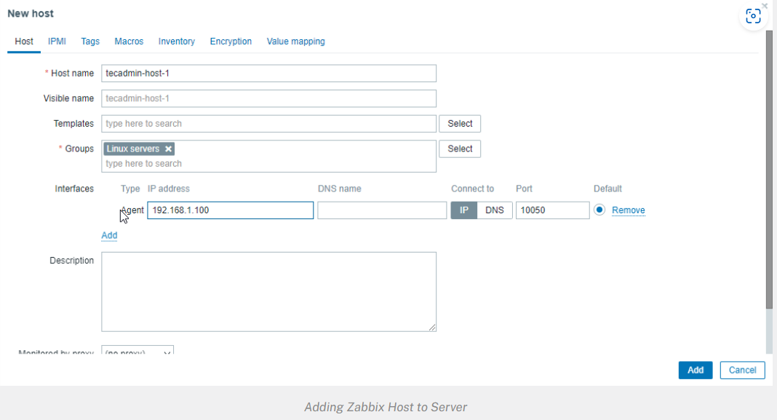

Then go to **Templates** tab.

1. Click the select button and Link new templates section

Select the template you want to use.

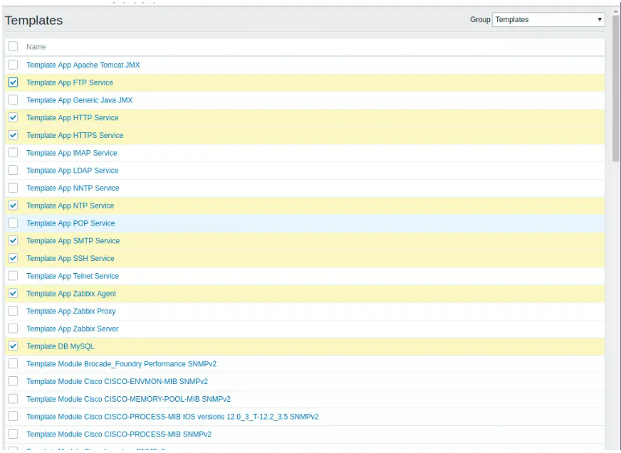

Once you have selected the templates click on the **Add** link to link templates to your target system After the templates are linked, they’ll appear on under **Linked templates** section

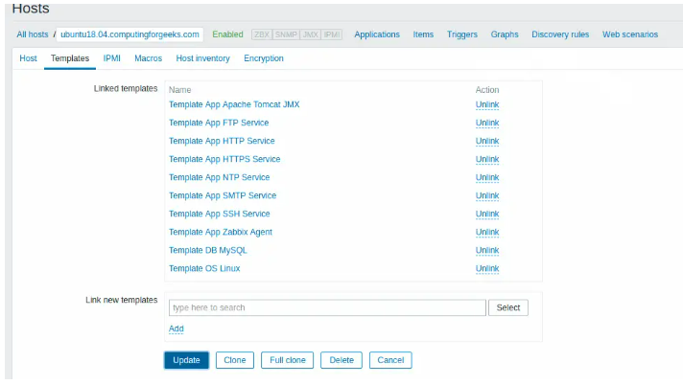

Update the setting using **Update** button. After few minutes, monitoring data will be collected and you can visualize them using Zabbix graphs.

**Monitoring > Graphs > <Host|Graph>**

